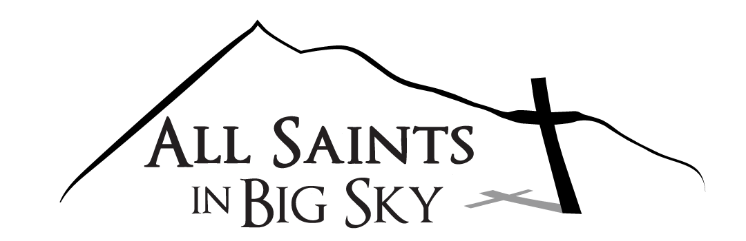
A Shared Ministry of the Episcopal and Lutheran (ELCA) Churches
April 30, 2020

Dear Members and Friends of All Saints in Big Sky,

At an April 28 meeting, the All Saints in Big Sky Joint Council voted unanimously to continue the suspension of live chapel services and all other official church meetings and gatherings until the state of Montana has successfully navigated the phased reopening requirements of Phase I and has entered Phase II.

The decision to suspend services until further notice, that was made over a month ago, was a difficult one for church leadership and staff. However, it has been wonderful to see how Pr. Miriam, Pr. Valerie, Sarah, Bonnie and Debbie have continued our ministry through online home worship, prayer, bible studies, meetings and continuing our support of the Big Sky community in these difficult times.

The need for the Joint Council to consider a revision to the March 17 suspension decision was necessitated by Governor Bullock’s April 22 directive and guidance for a phased reopening of Montana and the establishment of conditions for Phase I. This directive specifically allowed places of worship to resume live services beginning on April 26, but under strict social distancing and gathering rules.

Immediately following the Governor’s Directive, guidance for resuming services was received from our Bishop of the Montana Synod of the ELCA – Laurie Jungling and our Bishop of the Episcopal Diocese of Montana – Marty Stebbins. In addition, the Big Sky Chapel Board has now issued rules of use for the chapel in order to comply with the Governor’s Directive in Phase I. Based on the directive and official church guidance, it became clear that any service held during Phase I would have to comply with the following;

- All vulnerable individuals should continue to follow the stay at home guidance so should not attend a chapel service. “Vulnerable Individuals” is defined as people over 65 years of age, people with serious underlying health conditions, including high blood pressure, chronic lung disease, diabetes, obesity, or asthma, and people whose immune system is compromised such as by chemotherapy for cancer or other conditions requiring such therapy.
- Physical distancing between family groups must be maintained within the sanctuary.
- Masks must be worn by all those attending the service.
- Traditional communion will not be possible.
- Singing is not recommended and will be difficult at best.
Based on the vision of such services, as well as the discussion we have had with other Big Sky and Bozeman churches, and the success of our current online and community support practices, the Joint Council is convinced that continuing as we are until Phase II is reached is the best policy for us at this time. The Joint Council continues to hold virtual meetings every two weeks during the crisis and will revisit this decision at each meeting. If you have questions, comments or would just like to talk about this further, please feel free to email or call me or any member of the Joint Council; members are Erin Bevan, Colleen Cleary-Boyer, Ginna Hermann, Dennis McCarthy, Ann Scheder-Bieschin, Kim Ranstrom, Bill Vetter and Pat Miller.

We continue to believe that though we are physically distant from each other these days, we are still knit together in Christ, one body.

Pat Miller – All Saints in Big Sky Joint Council President

